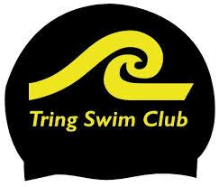
Coaches Incident Report Form

Please complete the information below for any ‘out of the ordinary’ incidents. As a guide this would include significant behaviour issues (eg where a swimmer has been asked to sit out part of the session); major accident where parents/guardians have had to be informed. The club will keep a record - including what you have done to resolve the issue, and in extreme circumstances initiate follow up action. On completion the form should be sent to the Welfare Officer, Head Coach and Chair.

Coach: ___________________________________

Date: ___________________________________

Session: ___________________________________

Brief description of the incident: __________________
____________________________________________
____________________________________________
____________________________________________
____________________________________________

Names of swimmers involved: ____________________
____________________________________________
____________________________________________
____________________________________________

Names of any witnesses: _______________________
____________________________________________
____________________________________________

Action already taken to resolve the issue: ___________
____________________________________________
____________________________________________
____________________________________________
____________________________________________
____________________________________________

Follow up required: Yes/No

